Slogan: Code, Troll and Rock and Roll



Team Members:

Beka
Diana
Firew
Alber

Revision History
Date | Version | Description | Authors
5/22/2017 | 1.0.0 | Initial draft of the design document | Alber Gerges  Behzodbek Qodirov  Diana Yamaletdinova  Firew Abebe

Table of Contents
1. Introduction 4
1.1 Scope 4
1.2 Purpose / Technologies used 4
2. Requirements – Use-Case – Usage Scenarios** 6
3. High Level Design 7
3.1. Integration Perspective 8
4. Detailed Design 10
4.1 Integration 10
4.2 Scalability 10
4.3 Interaction Diagram 12
5. Issues, Risk and Dependencies 13
6. Future Considerations 15
7. References 16

Introduction

Coding Trolls build a messaging application ‘TrollApp’ that utilizes all the technologies we used/learned in class.

Scope

The basic functionality of the application is chat conversation. After the user logged in he can choose users to whom send the message. Ideally, it can be one or multiple users. The messaging is done through the Rabbit MQ and, ideally, there is no limit to the number of clients that can use the application at the same time. One other functionality is to add users and view the users existing in the database. To add a new user is limited to certain categories of the users, for example admin.
The system should cater the testing facility to Java/JEE technologies. We implemented spring integration through chatting application using different spring technologies.

Purpose / Technologies used

The purpose of this project is to demonstrate the proof of concept in enterprise applications that we learned in class.

Concepts that have been implemented are:

- Annotation Driven Application
- Hibernate Persistence [JPA]
- Spring messaging using RabbitMQ
- REST web service
- ORM/hibernate handles the mapping of objects to database tables
- Security, Log in and Authorization
- Aspect oriented programming
- Batch
- Sprint Model View Controller pattern
- N tier model architecture
- JSR-303 Validation

These technologies are used to create coherent, reusable, maintainable, scalable application that meets best industry standards. The following paragraphs explain it in more details.
TrollApp is a web based messaging application that uses the N-tier Model Architecture and best practices of MVC pattern. It is annotation driven application is based on Hibernate technology and uses the AMQP messaging technology for inter-application communication that relies on asynchronous message-passing instead of synchronous request response-based architecture. RabbitMQ is an open source message-broker that implements the Advanced Message Queuing Protocol (AMQP) standard. Message broker provides features like persistent storage of messages, message filtering, message transformation, etc.
The main and important idea is that producer and consumer of messages are decoupled by an intermediate messaging layer known as the message broker (RabbitMQ). The core idea of the messaging model in RabbitMQ is that the producer never sends any messages directly to another client. In fact, producer sends messages to a RabbitMQ Server that resends these messages to the appropriate client.
The application also utilizes the REST architectural style to guarantee better scalability and availability due to server statelessness; better use of the standard services such as caching for instance; decoupling between client and server due to the use of a uniform interface and so on.
Application employs the JSR-303 validation when new user is registered in the system. The error messages are specified in the error handling file.
Aspect Oriented programming represented in the application as a logging functionality that displayed on the console.
Security is done to restrict some functionalities to specific users. For example, user has to be logged in to send the messages. When adding a new user, we provide the option to add authority to the users by adding a drop down menu with underlying roles such as ROLE_USER< ROLE_ADMIN etc. In the future releases this application can me advanced to utilize that functionality to create groups, add more specific use cases to different user, etc.
The domain classes has relationships mapped to reflect the class diagram displayed in the future section below. To implement entity relationships we used Java Persistence API and Java 5 annotations to handle data relationships in an object-oriented manner.

Requirements – Use-Case – Usage Scenarios**
Message
Intent | Chatting
Author | Firew Abebe
Last Update: | 5/22/2017
Primary Actor | Client1
Secondary Actors | Client2
Description | The client1 sends a message to RabbitMQ and RabbitMQ redirects the message to client2
Preconditions | - The client need to login and  - Authenticated by the system
Trigger | - When the client click send button
Success Post Condition | The client will successfully publish the message to the broker
Failed Post Condition
MAIN FLOW
Steps | Action
 | The client log to the system
 | The system will check the validation and passes to the server
 | The client publishes the message to the server
 | The server parses the message and identifies the receivers
 | Use case ends
RELATED INFORMATION
NOTES & ISSUES | **Note: Please see separate file for use case with details on how to run the project.

High Level Design

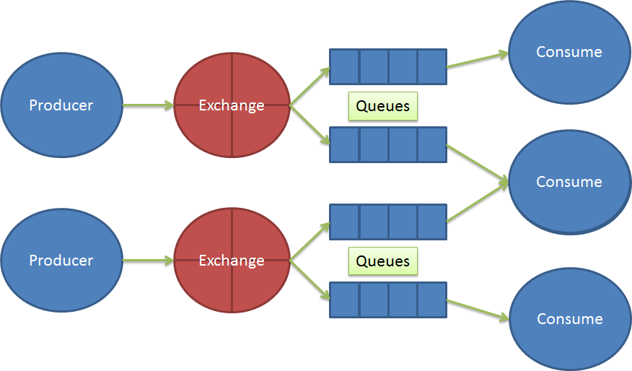

Figure: TrollApp architecture

This section of the document sets out at high level how the solution fits together and shows different views how the systems fit within the Enterprise.

Integration Perspective
Message Broker is an awesome solution for the well-known problem of high-coupled software systems that is communicated between modules. Message Broker creates an abstraction between modules, so that messaging functionality is controlled and managed by the Message Broker itself. Modules are not aware of the sending or receiving of messages; they only send their messages to the right receiver via Message Broker. Message Broker routes these messages to the right module and transforms them to the appropriate messaging format.

As a consequence, Message Broker is defined as messaging middleware that simply makes a transition of high-coupled messaging modules to the low-coupled messaging modules by creating the intermediate layer between modules. As shown in the following screenshot, modules are sending and receiving messages from each other without knowing the functionality of the intermediate layer, which sends the messages to Message Broker and routes them to the right module. For example the Message model simply expresses who sends the message, called the "from" variable in our class; who receives the message, called the "to" variable in our class; header; content; and message number that denotes the unique message number sequence.

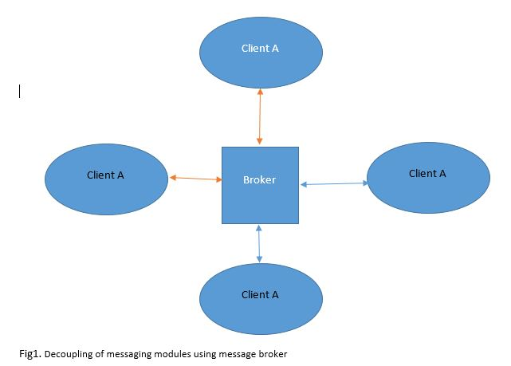
This is a high level diagram that represents the idea behind our application. We have one server broker that receives all the messages from all the clients and redirect them to the appropriate client.
Client also have Rabbit MQ running on their machines. However client does not know anything about other clients, it only knows about the broker (server), the server on the other side knows about the clients and sends messages to the right ones.

Detailed Design

Integration

RabbitMQ is used as a Broker. This Message Broker has a capability to send and receive messages without analyzing the details of the sender and receiver. Message Broker just sends the messages in a given format to the right module. Message Broker just gives us the combination of different stacks into one architecture, and it gives us another solution for well-known software engineering problem: Interoperability.

Scalability

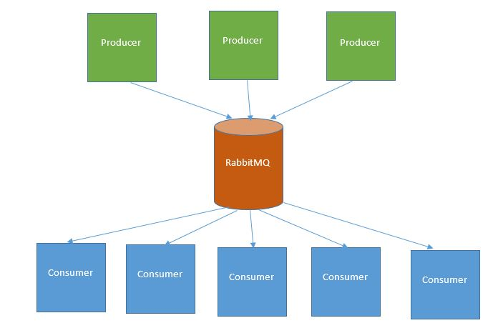
RabbitMQ Broker eases the problem scalability by delivering high throughput, less response time, and highly concurrent system. The system design guarantee that the message is sent and received, since each of the messages is very important for our system's robustness. Message Brokers (RabbitMQ server) and the database will store all messages to satisfy this kind of requirement. You can see the overall diagram of the software architecture with the following.

In our case the scalability factor is met in this way:
- we can have as many clients as we need and the only thing they need to know about is the Server and its queues. Thus, by adding the dynamic queues in the future, we can scale our application to the bigger auditorium.

The In Organizational Messaging system is used for organizational integration through messaging and the systems runs different server and a client or groups of clients can exchange messages in the organizational. We have domain classes for the core the system application, a replica domain object in the REST client and for the integration and messaging system we also have basic domain classes. The below diagram shows the model class interaction and the level of associations between them.
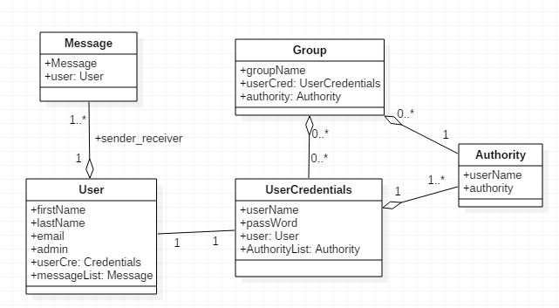

Interaction Diagram

The following system sequence diagram shows how a single message is sent to the right user. We can see that Client1 sends a message to Client2. After that, a Message Sender object sets the routing key of the Message Broker, which is TrollsAppMqServer in our case, who sends the message through the RabbitMQ Server. RabbitMQ finds the right client using the routing key, then sends the message to the message listener called Message Receiver. Finally, Message Receiver publishes the message to the attached client, which is Client2 in our case.
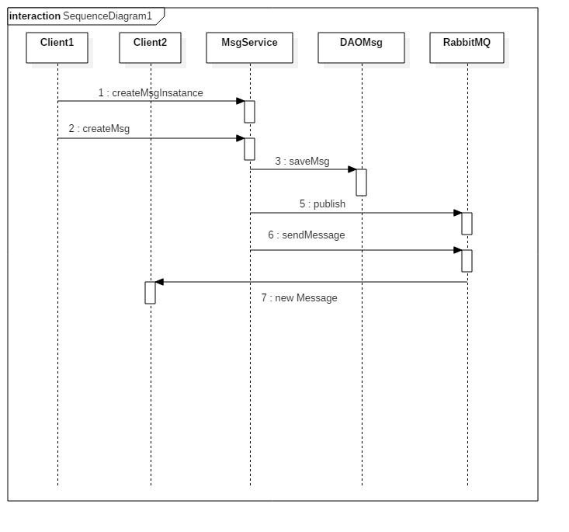
Fig1 InOrganizational Messaging app sequence diagram

Issues, Risk and Dependencies

Distributed RabbitMQ is a very complex operation. As a team we made a decision not to distribute the messaging broker since it is not needed for this project. And furthermore, the suggested implementation by one of the team members was not making use of one of the core functionalities of RubbitMQ (the build in exchange routing). This team member ignored us and went ahead and spend days to do the research and try out different approaches. Despite the fact that distributed system worked, we believe this was not the right approach. Thus in the future, we would correct the flow.

Other issues we encountered:
- Creating a light weight serializable POJO for passing between clients is really a duplication of the same data attributes.
- Creating a dynamic queues was difficult to implement in the time we had. However, in the future, this will be added.
- We added all the dependencies, and the person responsible for it work hard to make sure we are using the latest releases and there is no unnecessary dependencies. It tool more time that we anticipated though.
- Implementing REST (distributed) was harder than we anticipated and we spend a lot of time putting the pieces together. On the bright side, REST integration is perfect, and has no any issues at all.
- When integrating Spring Security we spend some time to figure out how to make the user available throughout the application. So what we did is we saved an object to a session that can have values added and removed while the application is running. That’s where we saved logged in user info for future reference.

Future Considerations

We have been applied the best design principles and guidelines. Our application is fully integrated with REST and RabbitMQ and functions flawlessly. We implemented our application following the separation of concerns, usability, maintainability principles.

The following points will be considered to scale and expand the functionality of the application:

- Create dynamic queues when new user is added.
- Create a messaging groups on the fly, and utilizes the Groups functionality we learned in class
- Utilize Ajax to display message on the screen
- Provide an option to save message history

References

- CS544 class materials , Professor J.Bruen, (May 2017 Block Demos and lessons materials)
- RabbitMQ Cookbook, Gabriele Santomaggio
- Spring Security 3, Peter Mularien
- Spring Security tutorial
http://krams915.blogspot.com/2011/01/spring-security-3-full-acl-tutorial.html
- Text book: Spring REST. Balaji and Sudha
- Java persistence with hibernate, Second Edition 2015. Chirstian Baur, Gavin King, Gary Gregory
- Spring Framework Reference Documentation
http://docs.spring.io/spring/docs/5.0.0.M3/spring-framework-reference/htmlsingle/

